GRANT OF EASEMENT
(Storm Sewer Easement)

THIS GRANT OF EASEMENT (this “Agreement”) is made this ___ day of __________, 2017 (the “Effective Date”), by and between the PUBLIC SCHOOLS OF THE CITY OF ANN ARBOR, a public body corporate and school district incorporated and operated pursuant to Act 451 of 1976, as amended, whose address is 2555 South State Street, Ann Arbor, Michigan 48104 (“Grantor”), and RAINBOW RASCALS MI – ANN ARBOR NIXON LLC, a Michigan limited liability company, whose address is 1742 Crooks Road, Troy, Michigan 48084 (“Grantee”).

R E C I T A L S:

- Grantor is the owner of certain real estate located in the City of Ann Arbor, County of Washtenaw, State of Michigan, which is more particularly described on Exhibit A attached hereto and incorporated herein (the “Grantor Parcel”).

- Grantee is the owner of certain real estate located in the City of Ann Arbor, County of Washtenaw, State of Michigan, which is more particularly described on Exhibit B attached hereto and incorporated herein (“Grantee Parcel”). The Grantor Parcel and the Grantee Parcel are sometimes hereinafter referred to as Parcels.

- Grantee desires to construct a storm sewer, sewerage, piping and other storm sewer apparatus and related improvements for the benefit of the Grantee Parcel (collectively, the “Storm Sewer”).

- Grantor wishes to grant to Grantee (i) a temporary easement for the construction of the Storm Sewer over, across and within those portions of the Grantor Parcel depicted on the sketch and described on the legal description attached as Exhibit C (collectively, the “Temporary Construction Easement”), and (ii) an easement for use, maintenance, inspection, repair and replacement of the Storm Sewer over, across and within those portions of the Grantor Parcel depicted on the sketch and described on the legal description attached as Exhibit D (collectively, the “Storm Sewer Easement”).

- Grantor represents and warrants that it is the sole owner of the Grantor Parcel, that there are no lenders or others with an interest in the Grantor Parcel that have priority over this Agreement, and that Grantor has the right to grant the easement and dedicate the improvements as set forth in this Agreement.

THEREFORE, for and in consideration of the mutual covenants of this Agreement and other good and valuable consideration, the receipt and sufficiency of which is hereby acknowledged, the parties agree as follows:

- Grant of Temporary Easement. Grantor hereby grants to Grantee and its consultants, contractors, engineers, agents and employees a temporary easement over, across and within the Temporary Construction Easement for purposes of construction of the Storm Sewer located within the Storm Sewer Easement together with the right of access, ingress and egress over and across the Grantor Parcel and within the Temporary Construction Easement for purposes of such construction. The Temporary Construction Easement shall terminate ten (10) days after Grantee delivers written notice to Grantor that the Storm Sewer construction is complete.
- Grant of Permanent Easement. Grantor hereby grants to Grantee and its consultants, contractors, engineers, agents and employees, tenants, licensees and invitees a perpetual easement over, across and within the Storm Sewer Easement for purposes of use, maintenance, inspection, repair and replacement of the Storm Sewer located within the Storm Sewer Easement together with the right of access, ingress and egress over and across the Grantor Parcel and within the Storm Sewer Easement for purposes of such maintenance, inspection, repair and replacement.
- Maintenance of the Storm Sewer Easement. Grantee shall maintain, inspect, repair and replace the Storm Sewer. Grantee agrees to repair any damage to the surface of the Storm Sewer Easement resulting from its inspection, maintenance, repair or replacement of the Storm Sewer within the Storm Sewer Easement and to restore the Storm Sewer Easement to substantially the same condition existing prior to such work by Grantee, to the extent reasonably possible.
- Use of the Storm Sewer Easement. Neither Grantor nor its successors, transferees or assigns, shall construct any buildings or improvements nor place any trees on the Storm Sewer Easement nor make any change to the grade or surface of the Storm Sewer Easement without prior written notice to and approval by Grantee.
- Further Easements. Grantor will not grant any further easements within the Storm Sewer Easement nor alter, repair or modify the Storm Sewer without prior written notice to and approval by Grantee.
- Additional Documents. All parties agree to execute, acknowledge and deliver such other instruments, documents or agreements (in customary form, reasonably acceptable to the executing party) as shall be reasonably necessary in order to fully bring into effect the intent and purpose of this Agreement.
- Notices. Any notice, demand, request, consent, approval, designation or other communication made pursuant to this Agreement shall be in writing and shall be given or made or communicated by personal delivery, by United States registered or certified mail, return receipt requested, or by prepaid Federal Express or other recognized overnight delivery service addressed to the addresses set forth on Page 1 of this Agreement. Any notice, demand, request, consent, approval, designation or other communication so sent shall be deemed to have been given, made or communicated, as the case may be, on the date the same was personally delivered or delivered by the United States Mail as registered or certified mail, with postage thereon fully prepaid, or by Federal Express or other recognized overnight delivery service, or the date of refusal of such delivery, if applicable.
- Governing Law. This Agreement is executed in and shall be governed by, and construed under, the laws of the State of Michigan.

- Modification. This Agreement cannot be modified except by written instrument signed by both of the parties hereto.
- Headings. Section headings set forth herein are for convenience of reference and shall not be construed to interpret, limit or otherwise define the terms and conditions of this Agreement.
- Binding Effect. All rights, title and privileges herein granted, including all benefits and burdens, shall run with the land and shall be binding upon and inure to the benefit of the parties hereto, their respective successors and assigns.
- Counterparts. This Agreement may be executed in multiple counterparts, each of which shall be deemed an original and all of which shall constitute one agreement. The signature of any party to any counterpart shall be deemed to be a signature to, and may be appended to, any other counterpart.
[Signature and Notary Pages Follow]

[Signature Page to Grant of Easement]

IN WITNESS WHEREOF, the undersigned have executed this Grant of Easement as of the day and year first above written.
GRANTOR:
PUBLIC SCHOOLS OF THE CITY OF ANN ARBOR, a public body corporate organized and existing under the Michigan Revised School Code

By:
Name:
Its:

GRANTEE:

RAINBOW RASCALS MI – ANN ARBOR NIXON LLC, a Michigan limited liability company

By: Pat & Sons Consolidated, LLC, a Michigan limited liability company, its sole member

By:
Reed Fenton, Authorized Representative

[Notary Page to Grant of Easement Follows]

[Notary Page to Grant of Easement]

State of Michigan )
)SS
County of )

The foregoing was acknowledged before me this ____ day of ________, 2017, by _______________________, the _______________________ of the PUBLIC SCHOOLS OF THE CITY OF ANN ARBOR, a public body corporate organized and existing under the Michigan Revised School Code, on behalf of such entity.

Notary Public, County,
My commission expires:
Acting in County

State of Michigan )
)SS
County of )

The foregoing was acknowledged before me this ____ day of ________, 2017, by Reed Fenton, authorized representative of Pat & Sons Consolidated, LLC, a Michigan limited liability company, the sole member of Rainbow Rascals MI – Ann Arbor Nixon LLC, a Michigan limited liability company, on behalf of such limited liability company.

Notary Public, County,
My commission expires:
Acting in County

Drafted by and return to:
Samuel A. Schiffer, Esq.
Jaffe, Raitt, Heuer & Weiss, P.C.
27777 Franklin Road, Suite 2500
Southfield, Michigan 48034

EXHIBIT A

Grantor Property

Land situated in the City of Ann Arbor Washtenaw County, Michigan described as:

Part of and Commonly known as:
Tax ID No.:

EXHIBIT B

Grantee Property

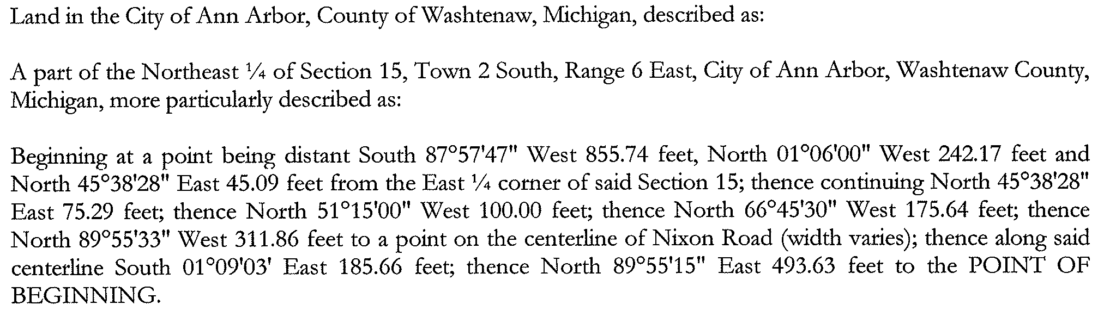
Tax Id Number: 09-09-15-100-036

Commonly known as: 2600 Nixon Road, Ann Arbor, Michigan 48105

EXHIBIT C

Temporary Construction Easement

DESCRIPTION OF TEMPORARY CONSTRUCTION EASEMENT:

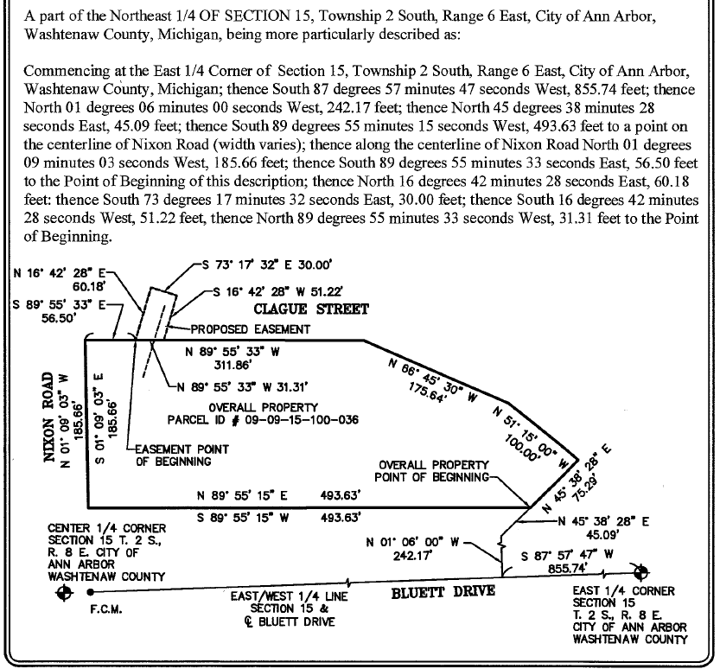

EXHIBIT D

Storm Sewer Easement

DESCRIPTION OF STORM SEWER EASEMENT:

